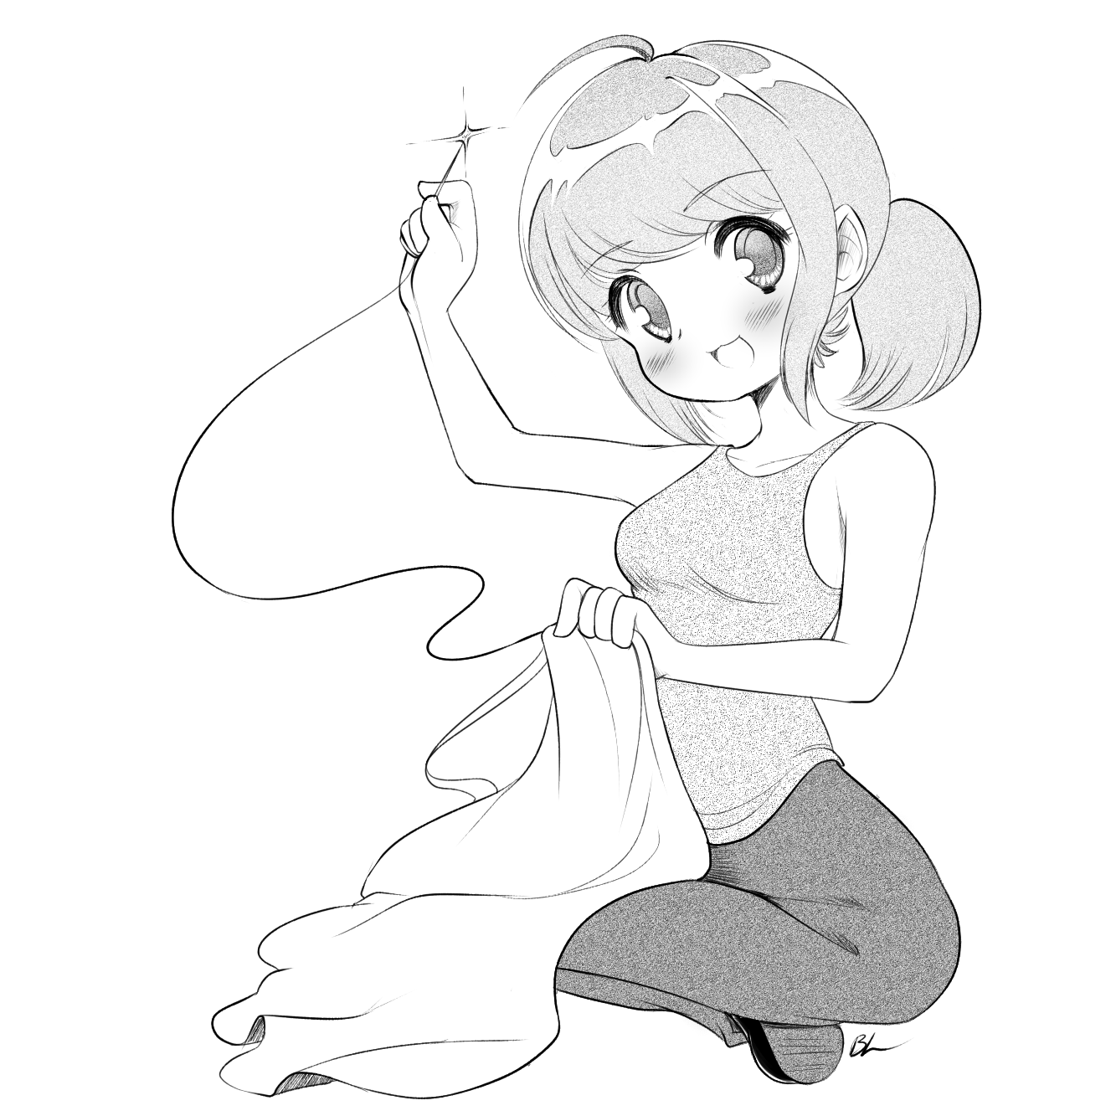
Cosplay Sewing Circle
2nd Saturday of the month*
12:00 pm-5:00 pm. Free. Bring a snack to share, if you like.
LASFS Back Room, 6016 Tyrone Ave., Van Nuys CA
Art by Blanca Lindsey, 2015, used with permission. facebook.com/groups/CosplaySewingCircle *Except February
Cosplay Sewing Circle
2nd Saturday of the month*
12:00 pm-5:00 pm. Free. Bring a snack to share, if you like.
LASFS Back Room, 6016 Tyrone Ave., Van Nuys CA
Art by Blanca Lindsey, 2015, used with permission. facebook.com/groups/CosplaySewingCircle *Except February

Cosplay Sewing Circle
2nd Saturday of the month*
12:00 pm-5:00 pm. Free. Bring a snack to share, if you like.
LASFS Back Room, 6016 Tyrone Ave., Van Nuys CA
Art by Blanca Lindsey, 2015, used with permission. facebook.com/groups/CosplaySewingCircle *Except February

Cosplay Sewing Circle
2nd Saturday of the month*
12:00 pm-5:00 pm. Free. Bring a snack to share, if you like.
LASFS Back Room, 6016 Tyrone Ave., Van Nuys CA
Art by Blanca Lindsey, 2015, used with permission. facebook.com/groups/CosplaySewingCircle *Except February

